Shadow in the USA
Kay Plumb, author
Bob Hobbs, illustrator

www.shadowintheusa.com

About Kay Plumb:

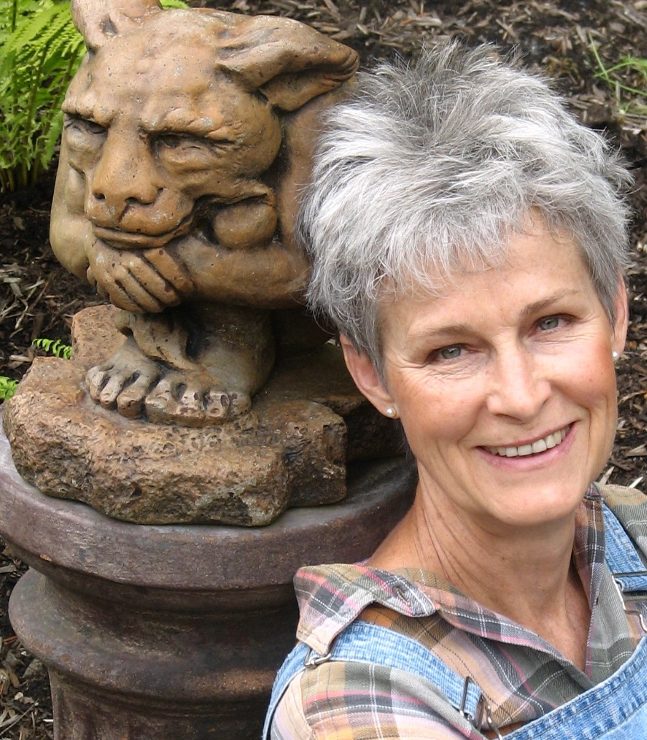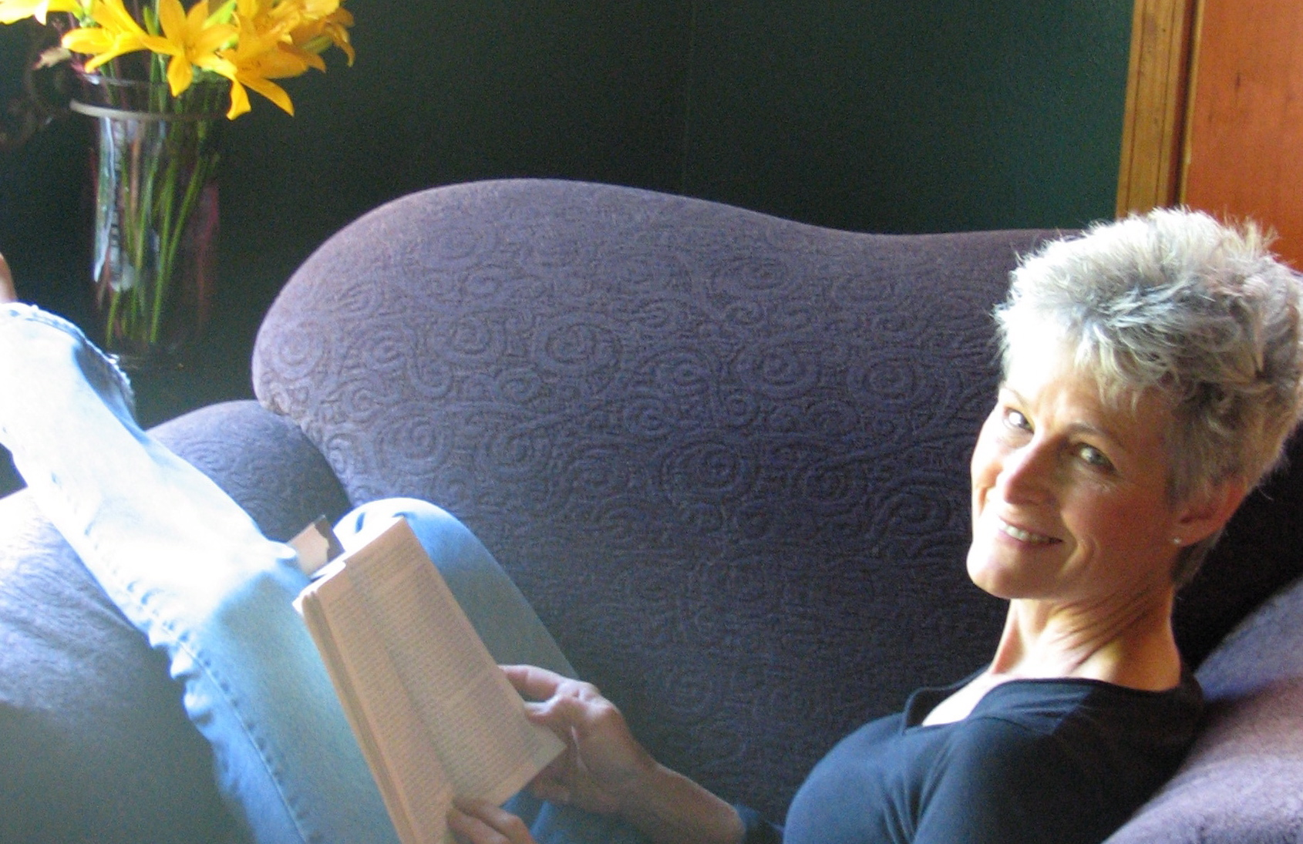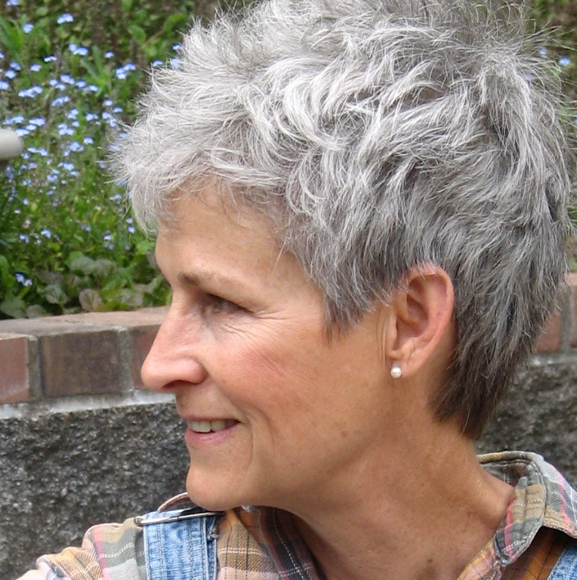
Q. Tell us a little bit about yourself:
I’m a lucky woman: good health, loving family, dear friends. I live in a quirky little house my husband and I rebuilt with our own hands that sits on 3 acres of wooded hillside which we passionately garden. Perhaps most important to the creation of this book, I’m a scholarly person by nature—a hermit and a forest dweller—who’s been focusing on one area of study for the last eighteen years.

Q. Tell us a little bit about your book:
Shadow in the USA is an illustrated book introducing a serious psychological subject. Which sounds odd, until you realize that as far back as the Middle Ages serious books—like the Bible—were heavily illustrated. So people would pay attention to them. And although we call it graphic non-fiction nowadays, it still operates on the same principal: a spoonful of beauty makes the medicine go down. Maus, by Art Spiegelman—which tells his father’s Holocaust story—would have been very hard to bear without Art’s illustrations.
Of course in modern times some works of psychological importance have been illustrated to great effect: The Power of Myth by Joseph Campbell; Man and his Symbols, by Carl Jung. It just isn’t done very often. It’s not the norm to illustrate psychology books. But the shadow is a gnarly subject, a terrifying subject, a subject most of us would rather not know anything at all about. So I knew it would take artwork to introduce us to our shadows, that it couldn’t be done with text alone. Particularly since our culture is so utterly inundated with visual images...
And I knew I would need a good story, a vehicle, to keep the subject moving. That, of all apparent contradictions, an introduction to the human shadow intended for the general public would have to be entertaining. The vehicle I chose is a classic version of “Beauty and the Beast.”

Q. What did you do to prepare for writing your book?
You can get a sense of it by perusing the “Recommmended Books” section at the end of Shadow in the USA. (This book list also appears on www.shadowintheusa.com) But the real truth is that I never will finish preparing to write this book. Trying to integrate one’s own shadow is a life-long task. You’re never done. We can never see our shadows completely or get rid of them entirely. Every ego casts a shadow. As Ursula K. LeGuin says in The Left Hand of Darkness: Light is the left hand of darkness, darkness the right hand of light.
To prepare for writing a book on the human shadow you have to be fallible—and capable of admitting it. In other words, you have to learn about your own shadow. You have to face the fact that you’re not just the Goddess of Wisdom, you’re also the Village Idiot. That, as Leonard Cohen says in “Bird on the Wire,” I’ve torn everyone who reached out for me.
The convoluted route that unrecognized shadow material takes through each of our psyches—first denial, then projection onto another, then blame—is the basic stumbling block to greater awareness that each of us face in life. We don’t want to know what is and isn’t our fault! We don’t want to see the darkness in our own souls. We want to be right, dammit! We long for the enemy to be elsewhere…
Problem is, the enemy ain’t. The enemy are us, as Pogo said. Whatever it is, it’s in your shadow because you don’t usually acknowledge it. Some parts of ourselves we like to advertise, put out into the light, and some parts of ourselves we try to hide, keep in the dark. Yours truly is no exception. So preparing to write a book on the human shadow can be rough going.
But getting to know your own shadow is also one of those delightful, inexplicable paradoxes that make life worth living: it’s the best—and the worst—thing that could possibly happen to you and your family.

Q. How did you develop your idea for this book?
It could be that the idea developed me. The zeitgeist we live in simply demands an introduction to the human shadow. Our species is not going to make it unless we smarten up—get more psychological, more self-introspective, a bit more conscious.
But my actual starting point was when a social worker here in Portland who works with troubled youth gave me audiocassettes of Robert Bly lecturing on the human shadow. Bombshell. Those tapes stayed in my car for over 6 months. Started up whenever I turned on the ignition. Played continuously, over and over, because I just couldn’t believe what perfect, soul-shattering sense they made. The kind of sense that hits you right in the gut. The kind of information that starts changing your life, whether you like it or not.
And because I just couldn’t believe I’d never heard of what Bly was talking about before. Nor had any of my well-read and intelligent friends ever heard of it before... Hhm… Odd… So I started looking around for the shadow. And when you start looking around for the human shadow, you run into quotes like the ones below:

Projection of shadow material causes most of the misery, injustice and warfare in the world. --Robert Bly

Learning to integrate shadow material is the single most important task facing mankind, as failure to do so will lead to the extinction of the human race. --Carl Jung

We need an essentially new way of thinking if mankind is to survive. --Albert Einstein

The task of confronting the brutal, destructive elements of the shadow has become the inescapable destiny of our species: if we fail, we cannot hope to survive. --Anthony Stevens

We might just be in time to stop the apocalypse. But it will be touch and go. --Konrad Lorenz

We are responsible for the effect of our actions, and we are also responsible for becoming as aware as we can of these effects. --Rollo May

The only devils in the world are those running around in our own hearts. That is where the battle should be fought. --Mahatma Gandhi

You spend enough time around material like that, it becomes pretty clear what you ought to try to do: you ought to try to promote a better understanding of the human shadow to the general public.

It is only when we have the courage to face things
Exactly as they are, without any self-deception or illusion,
That a light will develop out of events
By which the path to success may be realized. --I Ching
Q. Who was your publisher, and how did you chose them? Oh… that’s quite a story. Should be called The Perils of Self-Publishing...
I first started trying to interest publishers (and agents) in publishing a version of this book at least a decade ago. Right… Pretend, for a moment, that you’re a woman without a PhD. That you’ve been studying in obscurity all by yourself for years now while your friends have begun to wonder what in hell is wrong with you. Pretend you’re someone no one’s ever heard of, and that you’re writing on a subject no one wants to hear about… You can see how I managed to collect a stack of rejections.
Several years passed at this stage. People were unfailingly polite: Unique, original idea! Charming writing voice! But they also unfailingly declined: Unfortunately, I do not feel that I would be exactly the right person to represent this title… Even when they loved it—one man sent back my book proposal years later, saying it was so beautiful he’d kept it on his desk that whole time—no one was going to take a chance on me, or on a topic as scary as the human shadow.
Then my mother died—who knew she was worth anything?—and I received a small inheritance. That whole inheritance, due to my inexperience and naivete and whatever else you want to call making a ton of mistakes while putting all your money on the wrong horse, went to a “self-publisher” that we will simply refer to from here on out as He Who Must Not Be Named.
The man was as unscrupulous as he was unskilled. In the worst kind of way, the most dangerous kind of way, because he could not admit to either aspect of his being. Speaking of human shadow… As a Jungian psychologist said to me during this stage, Well what did you expect? Whatever you write about will constellate in your life. Why do you think there aren’t more books written on the human shadow? Because most Jungians are afraid to take it on! Great. Now they tell me.
When things got wacky enough I made a surprise visit to his place of business in Texas and discovered that HWMNBN’s “office suite” was a corrugated metal building on a gravel road 20 miles outside of Austin. His “design team” turned out to be his 18 year old daughter with a laptop. It was a nightmare. A living, breathing NIGHTMARE, for months. We’re talking my life’s work, my soul’s mission, and $5,000 of artwork by a fantasy master, being screwed up daily by someone who’d taken every last bit of my money and had no more idea what to do with it than I did.
Really!! Could I have been any dumber? Was I walking around with a “Fleece Me” sign on my back in those days?
I found myself with no editor, no designer, and 20 or 30 new typos every time he sent me a proof. Terrifying. So I ended up with a work of graphic non-fiction on a serious psychological subject that looked like a children’s book, and had no more money left to fix it. I only managed to get away from HWMNBN with my own copyright and ISBN by having a patent attorney friend of mine write him threatening letters. Otherwise, HWMNBN would have ended up owning my book. The one I had just paid him twice what I should have to produce and print. Otherwise, I would never have been able to produce this second, far better version, Shadow in the USA. (Moral: we should all have at least one friend who will write threatening letters for us on legal letterhead whenever we need it, for free.)
But then I had to form WorldView Press. Overnight. ISBN, LCCN, tax ID, all that other business—overnight. The book was actually lying on the press at the printer’s, waiting for my new copyright information to be placed on its outermost pages, so they could finish binding it. You see why my hair is so gray. And then I had to start trying to sell that poorly produced little book, called Using Beauty and her Beast to Introduce the Human Shadow, all by myself and without any more money.
Thank god for Peter Bowerman (self-publishing guru). I made every mistake “in the book” at least once, even following Bowerman’s directives. Yet somehow or other, despite the book’s flaws and my inexperience, people liked the book. It won a Bronze Medal in 2008 in the Independent Publisher Book Awards, in the Self-Help category. It won a Silver Medal in 2009 from The Young Voices Foundation, in the Inspiritational/Spiritual category. Psychologists liked it. Social workers liked it. The experts even liked it, and began to give me blurbs and advice.
But I still wasn’t proud of it. Winced over the ridiculously long title and the children’s book, fairy tale feel. Winced over some of the text. Knew it could be better. And I knew it would have to be better if I were actually going to reach the general public, if I were actually going to promote a better understanding of the human shadow, which was the whole point of this exercise.
So when the POD and ePub craze started, I called Bob Hobbs, the artist, who was not any more thrilled with what HWMNBN had done to our work than I was, and said... Ah… Bob… what if we did it over, ourselves? With a real book designer this time, in full color? With a revised and updated text that won’t go stale? Because POD means Print On Demand. It means you no longer have to print up a bunch of books all at once and then store them in a warehouse somewhere until they sell. You only print them up as you need them: print on demand. Much less expensive. And an ePub is instant. Once the original InDesign file is converted properly, an ePub is just a download.
And bless his dear, hard-working, faithful heart, Bob said Yes. Which is no small thing, since every one of those full page illustrations took him over 20 hours to digitally colorize, and since he also went back over every piece of line art, too, cleaning up and re-defining them for the new book. In fact, there’s absolutely no way I could afford to pay him up front for doing that much artwork, so Bob will be getting a 30% share of the net profits of Shadow in the USA.
So here we are. Poorer, wiser, a bit battered but far more experienced, launching Shadow in the USA.

