About the Artist

Bob Hobbs graduated from the University of Hawaii, and has been a professional artist since completing post-graduate work at the prestigious Rhode Island School of Design in 1974. He’s illustrated the works of over 130 different authors, and is hard at work on several more books right now, in addition to being a full-time graphic designer for the Centers for Disease Control in Atlanta, Georgia.
An acknowledged master in the field of fantasy art with its stunningly intricate and beautifully bizarre digital colorizations, Bob also enjoys illustrating simple children’s stories in pen and ink.
Whether working digitally, with watercolors, or with pen & ink, the man produces stunning artwork on a daily basis.

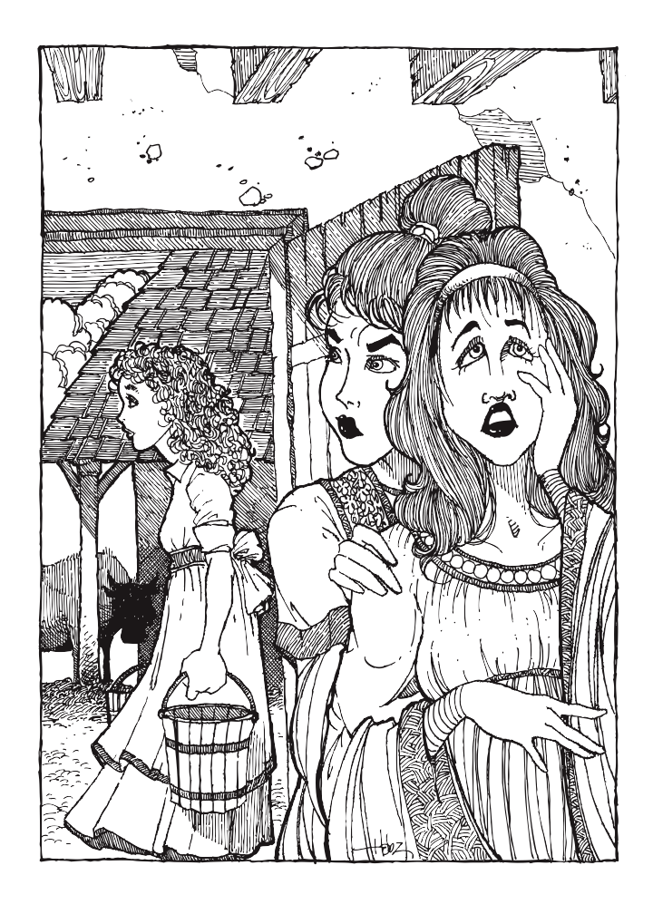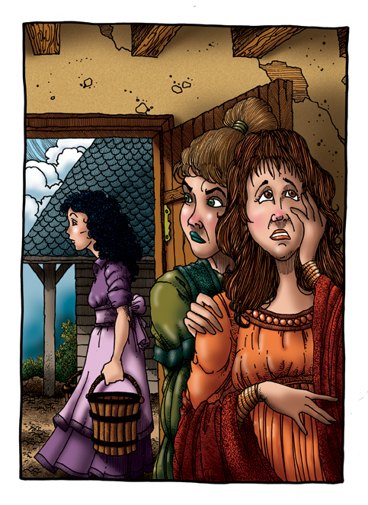

Bob, what was it like to work on this project?

“For me personally, it was an opportunity to get back to my roots as a pen & ink artist. I began using ink back in the early 70s, and pretty much built my reputation on my ability to create highly detailed, intricate drawings with ink. Then graphic computers came along in the 80s, and I jumped on that bandwagon, rather reluctantly at first.
And although I became quite proficient at digital and 3D graphics, I longed to get back to doing what I love most… feeling a quill pen in my hand and creating something with it on paper.
So when Kay came along and asked me to do the artwork for her book, I saw the chance to go back to old school illustration. I’ve always loved the works of classical book illustrators like Maxfield Parrish, Clement Coll, N.C. Wyeth, Arthur Rackham, and admired their amazing skills with pen and ink.
Since landing Kay’s gig, I’ve been offered 5 other book illustration projects by various publishers, and I plan to use my old rusty, trusty quill pens on these projects, too.
As far as the subject matter of Shadow in the USA goes, I found it fascinating. The dark half of nature and the universe is not necessarily the evil side, just the side that’s not as clear to us because we’ve spent so many life times ignoring it or shunning it. Mankind hates the dark side because he doesn’t understand it. He doesn’t understand it because he’s afraid to look at it.
Kay shines a big, bright orange Home Depot flood lamp on it and dares you to look.”

